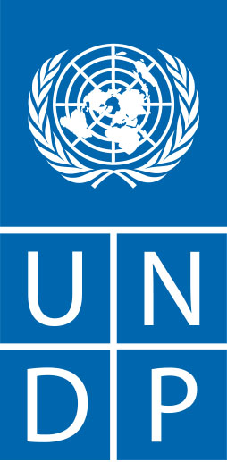
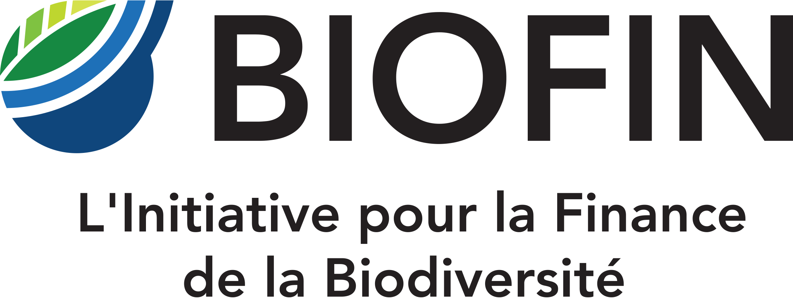
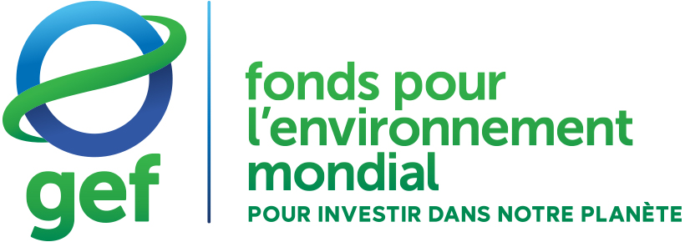
Country Results Report
The Biodiversity Finance Initiative (BIOFIN) programme in the Democratic Republic of Congo
REPORTING PERIOD: January to December 2025

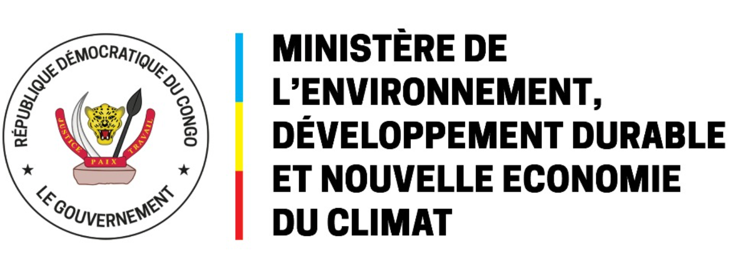

17 December 2025 Final Report

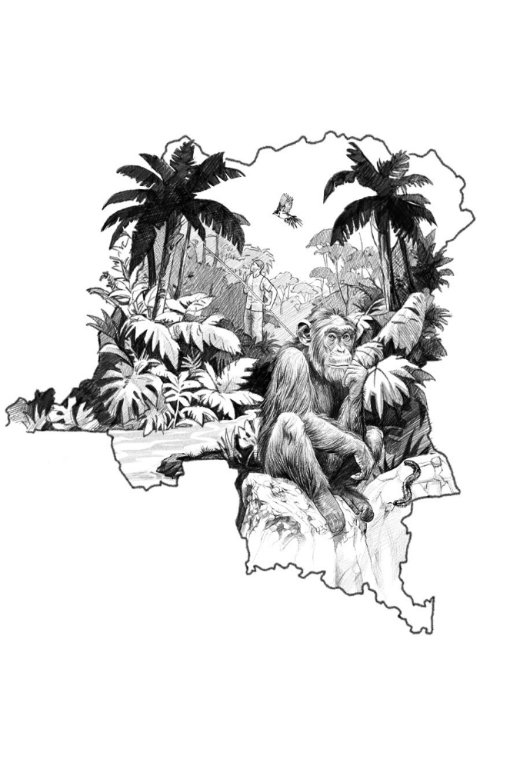

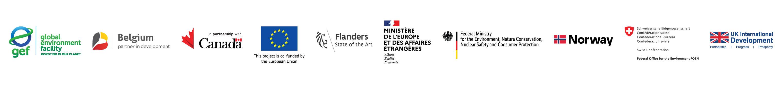

BIOFIN Country Profile

Country: Democratic Republic of Congo
Geographic coverage: Nationwide
Program Period: 2024 - 2027
Budget: 714 000 USD (314 000 USD du FEM and 400 000 USD from the French Government)

Table of Contents
Summary Erreur ! Signet non défini.
Country factsheet: the country's profile in terms of biodiversity financing and the programming approach 5
A.1. Biodiversity Financing Profile 5
A.2. National Implementation Context 7
B. Key results at a glance 7
B. PIR>BER>FNA>BFP 7
B.2. Implementation of financial solutions 7
C. Social inclusion stories 8
D. Lessons learned and adaptation measures 9
And. Risks 9
E.1. Programmatic risks (risks for the program) 9
E.2. Social and Environmental Risks (of the program) 11
List of Annexes and Notes 12
Appendix 1: Indicator Tracking Table (in Excel) 12

Executive summary
Progress toward targeted results
Validated BFP (following the validation of a PIR, BER, and FNA)
In March 2025, the entire BIOFIN national team was recruited, and work began on the implementation of the methodology, with a view to developing a biodiversity financing plan for the Democratic Republic of Congo.
Nine (09) months later, in December 2025, the following progress has been made:

- An approved work plan for the year 2025.
- With regard to the preparation of the Policy and Institutional Review (PIR) report: a scoping report with a roadmap is available defining the activities in stages and periodicity. At this stage, the consultant is in the process of finalizing the last part of the report.
- Regarding the preparation of the Biodiversity Expenditure Review (BER) report, the scoping report is available with a timetable for each stage. The study period is between 2019 and 2024. The data collection matrix is available and currently, the data is being collected to enrich the report which should be available by the end of the first quarter of 2026.
- Regarding the preparation of the Financial Needs Assessment (FNA), the BIOFIN national team has been closely engaging with the partners and national team who worked on the revision of the NBSAP. For the DRC, the NBSAP has been approved by the Congolese authorities. BIFOIN has organized several meetings with stakeholders to review the level of details of the NBSAP: the Secretary General for Environment, Sustainable Development and the New Climate Economy (MEDDENC), the GIZ team, WCS experts and colleagues from the United Nations Environment Programme (UNEP). It has been agreed that the NBSAP will request addition efforts to detailing an Action plan and logical framework allowing the costing of the activities. At the same time, consultations are being conducted by the Consultant to build this financial needs assessment (FNA) with public institutions but also with certain financial partners involved in the biodiversity sector.
- From 20 to 23 October 2025, an initial meeting of the technical committee was held to present the initial results of the PIR and the BER and to initiate dialogue with the various stakeholders. The final version of the PIR will be presented in January 2026, for technical approval and then validation by the Steering Committee.
- A ministerial order constituting the members of the BIOFIN National Steering Committee must be signed by the Minister in charge of the Environment, Sustainable Development and the New Climate Economy. This committee will be composed of the general secretaries of various ministries, the heads of state public establishments, the heads of technical and financial partners, environmental civil associations, representatives from the private sector, and research institutes. The Committee will be chaired by the Secretary General for the Environment, with the Secretary General for Finance acting as Vice-Chair.

Financing solutions:
During the reporting period, BIOFIN DRC has engaged partners and stakeholders to identify opportunities for early implementation. Based on the preliminary result of the Policy and Institutional Review (PIR) and discussions with national stakeholders, the following opportunities have been identified:
Financing Solution 1: Strengthen the national framework for PPPs in protected areas in the DRC.
The proposed financing solution aims to promote public-private partnerships (PPPs) in protected areas (PAs) by developing a national strategic guide and strengthening the capacities of the ICCN. The objective is to provide the DRC with a framework, roadmap, and tools to identify investment opportunities, as well as to propose, negotiate, sign, evaluate, and renegotiate PPP agreements.

Although PPPs in protected areas have been operational in the DRC since 2005 (with more than ten agreements signed with non-governmental organizations), there is still no national strategic framework to enable a change of scale in order to replicate this model in many other protected areas in the country, to support biodiversity conservation and promotion, while insuring human rights are respected.
The finance solution will aim to provide direct support to the renegotiation of at least 2 agreements coming to their end. Pre-identified sites are:
- Salonga National Park
- Lubumbashi Zoological and Botanical Garden
- Garamba National Park
Today, the Finance solution proposal has been validated, the terms of reference for the recruitment of an International Expert and a National Expert are validated internally, and the project will launch the procurement process by December 20, 2025, following the validation of the Steering committee.

Other results and future prospects
BIOFIN DRC will continue to work with its partners to study financial solutions to be integrated into the FPB.

In addition to the Finance solution 1, the BIOFIN DRC team is working in designing other Finance solution for early implementation. At this stage 2 concept are under development and will be presented to the BIOFIN Global team and the steering committee for further discussions and validation:
- Potential Financing solution 2: Improving the collection of the Touristic fees to increase investment into Nature.
The Tourism Promotion Fund (FPT) is a fee for the development and promotion of tourism. Created by Ordinance-Law No. 83-038 of 28 September 1983, it has experienced several ups and downs in its management between the Office and the General Secretariat for Tourism.Maximizing FPT seems difficult to date, due to poor control of the sector. To remedy this situation, in 2020 the ONT has started to set up a digital collection mechanism. Unfortunately, the digitalization exercise has not be fully implemented and it is limited to only a part of the airlines tickets, thanks to which the monthly revenue is estimated at 850,000 US dollars. In order to maximize the fee, BIOFIN will explore the possibility to finalize the digitalization exercise in order to further increase revenues and advocate for increasing investment of these revenues into Nature.
- Potential Financing solution 3: Increase budgetary and financial transparency of Protected Areas in DRC
BIOFIN will explore the possibility, together with Expertise France and ICCN, to develop a proposal to strengthen budgetary and financial transparency of Protected Areas management at the site level in order to inform ICCN's monitoring, evaluation and decision-making process. This finance solution could strengthen the ongoing activities implemented by Expertise France who is supporting capacity building on this thematic at the central level. This close collaboration could be highlighted in the there-engagement of the Coalition for Conservation in Congo (COCO-CONGO) discussion platform at the national level, supported by Expertise France. BIOFIN and the Biodiversity Finance Plan could support the working group related to Biodiversity Finance.

- Other opportunities:
BIOFIN DRC supports integrating Biodiversity Finance into national planning and has helped develop a GEF-backed project to enhance governance, biodiversity conservation, sustainable tourism, and livelihoods in Upemba National Park, aiming to restore biodiversity while boosting local economies. The four-year, 4.7M project awaits GEF approval.

The Environmental Investment Fund (FIPE), established under DRC laws, finances environmental initiatives through eco-taxes, subsidies, international contributions, and fund revenues.

The FIPE is the financial tool of the Ministry of Environment in the DRC to implement environmental policies and ensure sustainable financing of ecological projects. National financial instrument: The FIPE is designed as the Government's global mechanism to achieve its environmental objectives. Sustainable financing: It provides sustainability, accessibility and flexibility to environment-related financing. Policy implementation: It supports projects that protect the environment, combat pollution, manage natural resources, and promote a resilient, low-CO₂ green economy. Administrative and financial autonomy: As a public institution with legal personality, it can directly manage funds and support national initiatives.

Legal Framework: Creation: Law No. 11/009 of 9 July 2011 on the protection of the environment. Organization: Decree No. 20/031 of October 31, 2020, establishing its statutes, organization and functioning. Supervision: Ministry of Environment and Sustainable Development (MEDD).

Strategic role for the Department: (i) Channeling donor, private sector and environmental tax funding to priority projects. (ii) Strengthen environmental governance by centralizing resources and avoiding the dispersion of funding. (iii) Support the implementation of international commitments (Convention on Biological Diversity, climate, etc.) (iv) Complement other existing financial mechanisms, by offering a sustainable and flexible structure.

FIPE seeks to clarify its institutional role, strengthen structures, and maximize sustainable impacts. An audit will evaluate its capacity to meet environmental goals, integrate socio-economic priorities, and assess impacts on sustainability and equity. FIPE aims to lead innovative financial mechanisms like carbon credits, green bonds, and the Tropical Forest Finance Facility, and seeks accreditation with international entities like the Green Climate Fund (GCF). A strategic audit will identify challenges and opportunities, offering actionable recommendations to enhance its capacities for effective climate and environmental financing. UNDP is recruiting an expert to support FIPE’s audit and organizational development. The result could identify potential actions that BIOFIN could support.

- Next steps:
The year 2026 will be key for BIOFIN DRC, and the following milestones are expected:
- Validation of 2 new FS proposals by January 2026
- National consultative workshop for the PIR and BER in January 2026.
- Finalization of the Policy and Institutional Review (PIR) by January 2026
- Finalization of the Biodiversity Expenditure Review (BER) by February 2026
- First Steering committee of BIOFIN DRC by March 2026
- Launch of the Finance solution 1 (PPP in Protected Areas) by March 2026
- Launch of the Finance solution 2 and 3 by March 2026
- Finalization of the Financial Needs Assessment (FNA) by March 2026
- Closing of the Finance solution 1 by December 2026

Country factsheet: the country's profile in terms of biodiversity financing and the programming approach
A.1. Biodiversity financing profile
The country's commitment to protecting its biodiversity and preventing further loss.

The DRC has adopted three previous NBSAPs. Although they have improved institutional coordination and mobilized funding, they have not been effective in stemming biodiversity loss, either in the DRC or globally.

The adoption of the Kunming-Montreal Global Biodiversity Framework (CMBKM) at COP 15 in 2022 and its strengthening at COP 16 (Cali and Rome, 2025) mark a turning point in international commitments to biodiversity. These commitments require countries, including the DRC, to revise their national strategies and accelerate the implementation of conservation and sustainable use measures.

By updating its NBSAPs for the period 2025-2030, the DRC is aligning itself with these global commitments, while taking into account national realities and specific local challenges. This new NBSAP takes a more integrated approach, focusing on resource mobilization, national capacity building and improved monitoring of commitments.

The country's financial profile, including fiscal space to finance biodiversity conservation efforts and the funding gap if known.

The initiatives below show a growing commitment, but the DRC still needs to close regulatory gaps and foster inclusive and transparent management to ensure sustainable financing of its biodiversity.

The financial partners have carried out several flagship initiatives in favour of biodiversity. Below is a non-exhaustive description of these initiatives.

Okapi Fund for Nature Conservation: it is the first private trust fund dedicated to biodiversity conservation in the DRC, launched in 2019, at the initiative of the Congolese Government and with the financial support of the World Bank, the GEF and the German Development Bank for a base capitalization of USD 7.4 million and EUR 15 million. Today, the capitalization of the Okapi fund was 28.5 million US. With prospects for the period 2023-2027, we would raise a total of: US$58 million for the Endowment Fund, US$2 million for the Sinking Fund and US$7 million for the Earmarked Funds compartment
That is US$67 million over the period in all sectors.

The Government has set up the Forest Investment Program (FIP): financed by the World Bank and the government for an estimated overall amount (~USD 300 million). This program will support land governance, agroforestry, clean cooking, monitoring/verification, and results-based financing.

In another window between the World Bank and the African Development Bank to support agroforestry, clean energy, community management initiatives: 421,000 beneficiaries and USD 55 million released in carbon credits. Total shared funding ~US$300 million, supported by CAFI, GEF, The Special Grant Facility for Indigenous Peoples and Local Populations (DGM), followed by an integrated REDD+ Project (~US$22 million, African Development Bank). And several other Green Climate Fund initiatives with funding from the Bezos Earth Fund in support of Phase 2 (Readiness 30x30), of the Carbon Credits market (voluntary markets).

Mai-Ndombe Emission Reductions Purchase/Sale Contract (CAVRE/ERPA): the signing of the contract in September 2018, has resulted in a reduction of 11 million emissions at a price of $5 per tonne. To date, $5,565 tC02 of verified emission reductions; the World Bank will take part of it and give it to the government which will look for a new buyer and can sell it at a higher price. The maximum planned value: up to USD 55 million, for a cumulative reduction of 29 million tCO₂ between 2018 and 2022. A first payment of USD 19.47 million was made to the Congolese Government in June 2025, on the occasion of the delivery of 3.89 MtCO₂ reduced. It should be noted that local communities, indigenous peoples, customary authorities and private (interlocked) projects are recipients of a share of the funds. A benefit-sharing plan is being implemented to ensure transparency and inclusion, with the prioritization of women and youth. Social and environmental mechanisms (complaint management, stakeholder engagement, etc.) are integrated into the programme's management instruments. National Implementation Context.

B. Overview of Key Findings

B.1. PIR>BER>FNA>BFP
PIR:
The Environmental Investment Fund (FIPE) enjoys recognized institutional legitimacy, consolidated by its legal framework established under Law No. 11/09 of July 9, 2011, and Decree No. 20/031 of October 31, 2020. This framework grants it the capacity to mobilize diverse resources, such as eco-taxes, eco-fees, state subsidies, contributions from international partners, and revenues from the management of environmental funds.
However, in an institutional context where several environmental funds coexist (FONAREDD, FFN1, FOCON2, FONAT3, etc.), FIPE would benefit from clarifying its role by defining its complementarity with these mechanisms and avoiding overlaps or institutional competition. The establishment of a functional organizational structure, with clearly defined responsibilities aligned with its mandate, would strengthen its positioning and maximize its impact.
As a country of mega-biodiversity, the Democratic Republic of Congo must: (i) Highlight its extraordinary wealth in terms of biodiversity by taking urgent measures to conserve it and ensure the sustainable use of its constituent elements; (ii) Ensure that all stakeholders and relevant sectors fully and effectively participate in the decision-making process, using biodiversity rationally to transform it into a source of wealth creation and a strategic economic asset, notably through the development of value chains for the processing of raw products; (iii) Improve the management of existing protected areas and promote Other Effective Area-Based Conservation Measures (OECMs); (iv) Reconcile biodiversity conservation imperatives with development needs by mobilizing resources from reliable international and national sources, both public and private, direct and indirect, for the benefit of biodiversity, human well-being, and planetary health.
BER
The scoping report is available, along with data on public expenditures, already integrated into the matrix to facilitate a better interpretation of investments dedicated to biodiversity. The observations provided by the global team will allow the incorporation of quantitative data from technical partners. The report must be submitted for technical approval and validation by the steering committee before the end of the first quarter of 2026.
FNA
Following the technical consultation session with stakeholders in October 2025, the two consultants continued more sectoral consultations with these same stakeholders to collect the data needed to finalize the reports on Policy and Institutional Review (PIR) and Biodiversity Expenditure Review (BER). At this stage, the data collection matrix of the DRC's public expenditure related to the protection and conservation of biodiversity, as well as the summary analysis of some trends for the period 2020-2024, are being examined before their validation by UNDP. Expenditure data from official development assistance and the private sector are being integrated into the matrix.
The National Biodiversity Strategy and Action Plan (NBSAP), duly approved, remains a crucial reference document as it serves as the official roadmap for aligning national actions with the international commitments under the Convention on Biological Diversity (CBD).
As part of the assessment of needs and the estimation of financial costs related to biodiversity, the project convened several consultation meetings with key stakeholders: the Secretary-General for Environment, Sustainable Development and the New Climate Economy (MEDDENC), GIZ team, WCS experts, and colleagues from the United Nations Environment Programme (UNEP). The objective of these exchanges was to reach consensus on the methodology for the annual budgeting of the NBSAP, a process scheduled to begin in 2026.
The process of developing the Biodiversity Finance Plan will commence in the first quarter of 2026.

B.2. Implementation of financial solutions
The project has finalized the drafting of the terms of reference and plans to launch the recruitment process in early January 2026 to recruit: (i) an international consultant to support the development of a national PPP strategy and strengthen ICCN's capacities ;(ii) a national consultant to analyze the gaps in the existing legal and institutional framework and make proposals for improvement.

C. Social inclusion stories
Social inclusion in the context of biodiversity financing in the Democratic Republic of Congo (DRC) is a crucial issue, given the strong socio-economic inequalities, cultural diversity, and the fundamental role of local and indigenous communities in the management of natural resources. The Biodiversity Finance Plan (BFP) will take into account existing initiatives and strengthen participation illustrating social inclusion approaches in the DRC.
The DRC aims to achieve social inclusion goals by aligning its BIOFIN and other national initiatives with the overall goals of the Climate Promise, Gender Equality and the Nature Pledge, with a focus on biodiversity conservation.

Inclusive Financing and Governance Mechanisms
In the DRC, BIOFIN is setting up inclusive financing mechanisms and participatory governance to sustainably mobilize resources for biodiversity, involving the State, the private sector and local communities.
Inclusive financing mechanisms: through the Global Biodiversity Framework Fund (GBFF) of the GEF 8 replenishment cycle, BIOFIN, via UNDP, offers three financial solutions: (i) payment for ecosystem services (PES); (ii) the strengthening of public-private partnerships for the sustainable management of natural resources between ICCN and the Forgotten Park Foundation for the management of the Upemba National Park; (iii) eco-tourism, which includes local and indigenous communities in the projects financed, so that the benefits reach the actors on the ground directly.

Social Inclusion will integrate local communities (including indigenous peoples such as Pygmies) in the design and implementation of activities (reforestation, agroforestry). Support should continue through community governance structures that have been created with European Union resources to ensure the equitable representation of women and vulnerable groups in the management of funds and land.

D. Lessons Learned and Adaptation Measures
Adaptation measures planned by the Democratic Republic of Congo
A draft Ministerial Order is being signed at the Office of the Minister in charge of the Environment, Sustainable Development and New Climate Economics, to set up the National Steering Committee or the National BIOFIN Steering Committee, which will include intersectoral speakers or stakeholders and representation of financial partners, civil society and the private sector. This committee will play a crucial role in promoting collaboration between ministries, civil society and private sector stakeholders. To ensure active and regular participation, a Technical Committee comprising experts from the institutions, as well as focal points is already set up and operational. This Committee's role will be to provide technical expertise to the various deliverables of the project.

Plans for the Coming Period
The project will focus on the final development of reports on:

- (i) the analysis of policies and institutions,

- (ii) the mapping of existing financial mechanisms and financing needs,

- (iii) the analysis of trends and direct, indirect and underlying drivers of biodiversity change, before leading to the development of a national biodiversity financing plan for the DRC.

The DRC plans to organize a national workshop to launch the process, followed by a capacity building session for stakeholders in January 2026.

E. Risks

E.1.Programmatic risks (risks to the program)
Political and security instability can have an impact on the implementation of activities in areas with high biodiversity potential, but affected by armed conflicts, particularly in the east of the country. The efforts of the central government to sign a peace agreement with Rwanda, with the support of the United States, are to be welcomed.

Table 1. Risk Register for BIOFIN in the Democratic Republic of Congo
# | Description | Date of identification | Type | Impact &  Probability | Countermeasures / MNGT Response | Owner | Submitted, Updated By | Last updated | Status
1. | Political changes such as change of government after elections | Project Formulation | Politics | The Congolese did well do well in the presidential and legislative elections in December 2023. It should be noted that the ruling party carried by the Presidential majority was declared the winner of the presidential and legislative elections. After nearly 9 years of major military inactivity, the M23/AFC rebel movement resurfaced in November 2021 in the territories of Rutshuru and Nyiragongo, in North Kivu.  P= 2  I= 2 | The Presidential majority governs the country and all the institutions. Political and security instability can have an impact on the implementation of activities in areas with high biodiversity potential, but affected by armed conflicts, particularly in the east of the country. The central government's efforts to sign a peace agreement with Rwanda, with the support of the United States, are to be welcomed, but will not affect the project | UPAQ/ Monitoring and Evaluation Entity of the Country Office | Benjamin Ebuela Balongelwa  BIOFIN Coordinator | 08.Dec.2025 | No change
2. | The economic challenges faced by governments could take precedence over increased funding for biodiversity. | Project formulation | Financial | At the writing stage of this report, for 2024 and 2025, the International Monetary Fund forecasts sustained growth of around 6-7%, despite an uncertain global context, high probability of obtaining a subscription from stakeholders (Government + Financial Partners) and the project will not be able to influence this process.  P= 4  I= 4 | The financial solutions that will be proposed in the Biodiversity Financing Plan, for example: (i) strengthening the governance of the public and private partnership for biodiversity conservation, the terms of reference for the recruitment of an international expert and a national expert are validated internally, and the project will launch the procurement process by December 20, 2025. (ii) The project is currently exploring the possibility of supporting this financial solution of reforming taxes and fees in tourism. This fee is collected by the National Tourist Office, the project will provide support to enable the Office to increase revenues, it should be noted that 7% of this fee is intended to support biodiversity protection activities. | UPAQ/ Monitoring and Evaluation Entity of the Country Office | Benjamin Ebuela Balongelwa  BIOFIN Coordinator | 08.Dec.2025 | No change
3. | The risk of non-approval of national biodiversity financing plans | Project formulation | Strategic | The situation may exceed the limits of responsibility of the project, as this is governed by national political processes independent of the project's influence. The validation of the DRC NBSAP by the Prime Minister is a very strong commitment by the Government to its commitments in favor of Biodiversity. The launch of the 30x30 process is a strong commitment by the Government he CBD processes could go a long way towards mitigating this risk by encouraging Parties to sign documents as soon as possible and by strengthening political commitment.  P= 2  I=2 | It is expected that the foundations laid by this project will facilitate the identification and development of specific projects to implement national biodiversity financing plans through funding from the GEF, French funding and other donors as a result of this project. The various financial solutions that the project will propose will certainly find financial support either from financial partners or from the Congolese Government or philanthropists. | UPAQ/ Monitoring and Evaluation Entity of the Country Office | Benjamin Ebuela Balongelwa  BIOFIN Coordinator | 08.Dec.2025 | No change
4. | Risk of fraud and corruption | Project formulation | Reputation | The project is a DIM project and 100% implemented by UNDP, i.e. strict compliance with the relevant control mechanisms provided for in the UNDP policy against fraud and other corrupt practices to ensure the early identification and management of conflicts of interest. UNDP procurement rules based on the key procurement principles set out in the UNDP Financial Regulations and Rules are applied.  P = 2  I=2 | Overall, in accordance with the project document, the project committee must ensure the highest levels of fairness, integrity and transparency and take all measures to avoid any real or perceived conflict of interest. | UPAQ/ Monitoring and Evaluation Entity of the Country Office | Benjamin Ebuela Balongelwa  BIOFIN Coordinator | 08.Dec.2025 | No change

E.2.Social and Environmental Risks (of the Programme)
The BIOFIN programme implemented by UNDP with stakeholders does not create additional social and environmental risks. Indeed, the programme strives to mitigate existing risks by integrating UNDP's programming principles for strengthening social and environmental sustainability (SESP), and the programme is directly aligned with Standard 1 of the project-level standards, namely biodiversity conservation and sustainable management of natural resources.

List of Annexes and Notes
The following appendix is included in this report:

